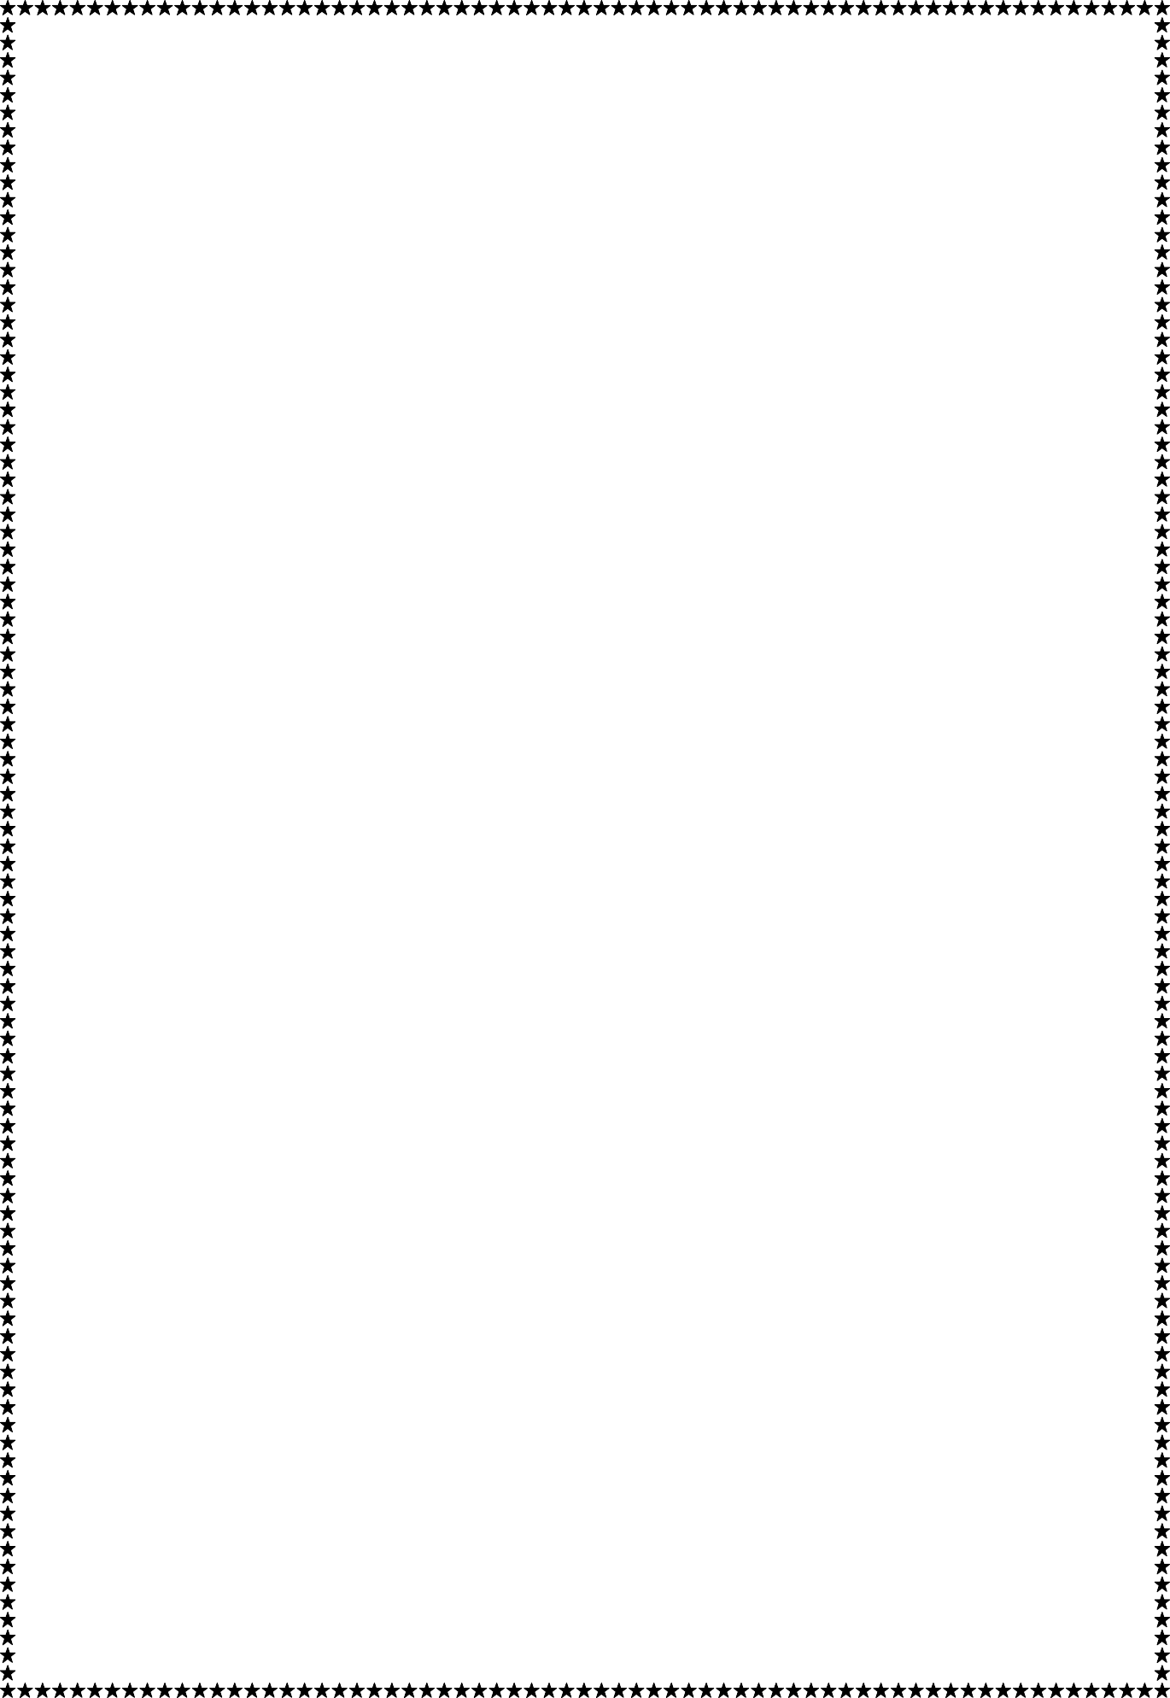

SESSION 2022-23

Python

(Hotel Management System)

Project File

**COURSE:- BCA**

**ROLL NO :- 41221139**

**SUBMITTED BY :- SUBMITTED TO:-**

**Sachin Rajbhar Ms. Kiran Dhangar**

**INDEX**

|  |  |
| --- | --- |
| **S. No.** | **Title** |
| 1 | Introduction Of Project and Requirements |
| 2 | Source Code |
| 3 | Screenshots |
| 4 | References |
|  |  |

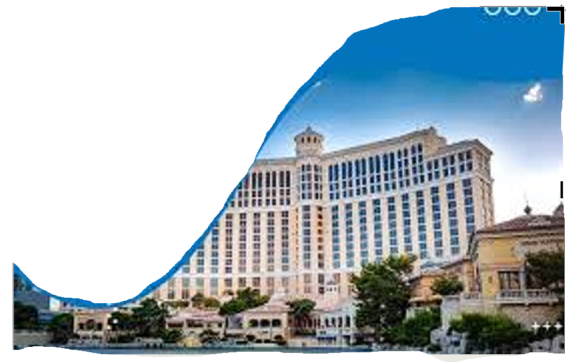

Introduction Of Project and Requirements

**# hotel-management-system**

**\*\*Hotel management system is an Tkinter based(Python module) application that can be used by any hotel to :-\*\***

-Reserve a room

-To get the status of room (i.e. available or reserved)

-To check the amenities available in the room

-To check the total number of guests in the hotel now

-To find the total number of available and reserved rooms

-To manage staff

-To find contacts of different authorities of hotel

-To find the payment information by providing the payment id

A filter is also provided which gives you the option to fill fields(amenities) according to the guest's choice and find the available rooms with the choosen amenities sorted in order from lowest price to highest price

**## Requirements**

```

python-3

```

Source Code

from tkinter import *

from tkinter import ttk

import time

import datetime

from PIL import ImageTk,Image

import os

import sqlite3

from tkinter import messagebox

now = datetime.datetime.now()

#----------- importing sqlite for server side operations---------------------------------------------------------------------------------

con = sqlite3.Connection('hm_proj.db')

cur = con.cursor()

cur.execute("create table if not exists hoteld(t_r number,r_r number,t_s number)")

cur.execute("create table if not exists roomd(rn number primary key,beds number,ac varchar(10),tv varchar(10),internet varchar(10),price number(10))")

#pmethod=0

#rstatus extra column

#for i in range (1,21):

#cur.execute("update roomd set tv='Yes' where rn = ? ",(19,))

cur.execute("create table if not exists payments(id number primary key,dot varchar(15),time varchar(10),amt number,method varchar(10))")

cur.execute("create table if not exists paymentsf(id number  primary key,f_name varchar,l_name varchar,c_number varchar,email varchar , r_n number ,day varchar,month varchar,year varchar,time varchar , method varchar,totalamt varchar)")

#cur.execute("insert into paymentsf values(1,'Sachin Rajbhar','Khare','9589861196','Sachin Rajbhar7673@gmail.com',2,'1','11','2018','11:20:27 PM','Cash','3500')")

#cur.execute("alter table paymentsf add totalamt varchar")

con.commit()

#cur.execute("drop table paymentsf")

#cur.execute("insert into hoteld values(20,11,30)")

con.commit()

cur.execute("select * from payments")

con.commit()

x=cur.fetchall()

con.commit()

#print(x)

#-----------splash_screen------------------------------------------------------------------------------------------------------------------

sroot = Tk()

sroot.minsize(height=516,width=1150)

sroot.configure(bg='white')

spath = "images/mypic.jpg"

simg = ImageTk.PhotoImage(Image.open(spath))

my = Label(sroot,image=simg)

my.image = simg

my.place(x=0,y=0)

Frame(sroot,height=516,width=5,bg='black').place(x=520,y=0)

#chilanka

Label(sroot,text="Hotel Management System ",font='Timesnewroman 40 ',bg='white',fg='black').place(x=535,y=10)

Label(sroot,text="Made by -",font='Timesnewroman 40 ',bg='white',fg='black').place(x=535,y=90)

Label(sroot,text="Sachin Rajbhar",font='Timesnewroman 40 ',bg='white',fg='grey').place(x=535,y=180)

Label(sroot,text="officialsachinrajbhar@gmail.com",font='Timesnewroman 40',bg='white',fg='grey').place(x=535,y=270)

#Label(sroot,text="9589861196",font='Timesnewroman 40',bg='white',fg='grey').place(x=535,y=450)

#----------- main project------------------------------------------------------------------------------------------------------------------

def mainroot():

#sroot.destroy()

root = Tk()

root.geometry('1080x500')

root.minsize(width=1080,height=550)

root.maxsize(width=1080,height=550)

root.configure(bg='white')

root.title("Made with love by Sachin Rajbhar")

#--------------seperator-------------------------------------------------------------------------------------------------------------------

sep = Frame(height=500,bd=1,relief='sunken',bg='white')

#sep.place(x=20,y=0)

#----------------Connection with printer-------------------------------------------------------------------------------------------------------------

def connectprinter():

os.startfile("C:/Users/TestFile.txt", "print")

#---------------top frame------------------------------------------------------------------------------------------------------------------

top_frame = Frame(root,height=70,width=1080,bg='orange')

path = "images/newestbg5.jpg"

img = ImageTk.PhotoImage(Image.open(path))

label = Label(top_frame,image = img ,height=70,width=1080)

label.image=img

label.place(x=0,y=0)

top_frame.place(x=0,y=0)

tf_label = Label(top_frame,text='Hotel Management System',font='msserif 33',fg='black',bg='gray89',height=70)

tf_label.pack(anchor='center')

top_frame.pack_propagate(False)

#---------------DATE TIME------------------------------------------------------------------------------------------------------------------

def datetime():

#while(True):

localtime = now.strftime("%Y-%m-%d %H:%M")

lblInfo = Label(top_frame,font='helvetica 15',text=localtime,bg='blue',fg='white')

#lblInfo.place(x=333,y=40)

#----------------bottom frame - hotel status and default page-------------------------------------------------------------------------------

def hotel_status():

global b_frame

b_frame = Frame(root,height=400,width=1080,bg='gray91')

b_frame.place(x=0,y=120+6+20+60+11)

b_frame.pack_propagate(False)

path = "images/newbg6lf.jpg"

img = ImageTk.PhotoImage(Image.open(path))

label = Label(b_frame,image = img ,height=400,width=1080)

label.image=img

label.place(x=0,y=0)

cur.execute("select * from hoteld")

x = cur.fetchall()

#print(x)

cur.execute("select count(rn) from roomd")

x = cur.fetchone()

print (x)

cur.execute("select count(rn) from roomd where rstatus = 'Reserved'")

y = cur.fetchone()

print (y)

tor = x[0]

rer = y[0]

tos = 21

avr = int(tor)-int(rer)

avr = str(avr)

#print(tor,rer,tos,avr)

hts = Label(b_frame,text='Hotel Status',font='msserif 15',fg='black',bg='gray91',height=1)

#------------inner frames of bottom frame-------------------------

smf1 = Frame(b_frame,height=150,width=175,bg='white')

tr = Label(smf1,text='Total Rooms:',fg='white',bg='cyan4',width=100,height=2,font='helvetica 15')

tr.pack(side='top')

smf1.pack_propagate(False)

smf1.place(x=0,y=30)

Label(smf1,text=tor,fg='cyan4',bg='white',font='msserif 50').pack(anchor='center')

smf2 = Frame(b_frame,height=150,width=175,bg='white')

ar = Label(smf2,text='Available Rooms:',fg='white',bg='cyan4',width=130,height=2,font='helvetica 15')

ar.pack(side='top')

smf2.pack_propagate(False)

smf2.place(x=180+4,y=30)

Label(smf2,text=avr,fg='cyan4',bg='white',font='msserif 50').pack(anchor='center')

smf3 = Frame(b_frame,height=150,width=175,bg='white')

tre = Label(smf3,text='Total reservations:',fg='white',bg='cyan4',width=130,height=2,font='helvetica 15')

tre.pack(side='top')

smf3.pack_propagate(False)

smf3.place(x=360+6,y=30)

Label(smf3,text=rer,fg='cyan4',bg='white',font='msserif 50').pack(anchor='center')

smf4 = Frame(b_frame,height=150,width=175,bg='white')

tc = Label(smf4,text='Total Customers:',fg='white',bg='cyan4',width=130,height=2,font='helvetica 15')

tc.pack(side='top')

smf4.pack_propagate(False)

smf4.place(x=540+8,y=30)

Label(smf4,text='40',fg='cyan4',bg='white',font='msserif 50').pack(anchor='center')

smf5 = Frame(b_frame,height=150,width=175,bg='white')

ts = Label(smf5,text='Total Staff:',fg='white',bg='cyan4',width=130,height=2,font='helvetica 15')

ts.pack(side='top')

smf5.pack_propagate(False)

smf5.place(x=720+10,y=30)

Label(smf5,text=tos,fg='cyan4',bg='white',font='msserif 50').pack(anchor='center')

redf1 = Frame(b_frame,height=8,width=1080,bg='cyan4')

smf6 = Frame(b_frame,height=150,width=175,bg='white')

ts = Label(smf6,text='Under renovation:',fg='white',bg='cyan4',width=130,height=2,font='helvetica 15')

ts.pack(side='top')

smf6.pack_propagate(False)

smf6.place(x=915,y=30)

Label(smf6,text='3',fg='cyan4',bg='white',font='msserif 50').place(x=60,y=60)

#redf1 = Frame(b_frame,height=8,width=1080,bg='cyan4')

#Label(b_frame,text='==================================================================================',fg='cyan4').place(x=0,y=20)

redf1.place(x=0,y=22)

Label(b_frame,text='Hotel Status',font='msserif 12',bg='cyan4',fg='white').pack(anchor='center')

redf1.pack_propagate(False)

#b_frame.pack_propagate(False)

#-----------------------------------------------------------------

nl = Label(b_frame,text='Made by Sachin Rajbhar',fg='black',bg='gray91',font='msserif 8')

nl.place(x=955,y=310)

nl.tkraise()

#-------------- Guests --------------------------------------------------------------------------------------------------------------------------

def staff():

b_frame = Frame(root,height=400,width=1080,bg='white')

path = "images/newbg6lf.jpg"

img = ImageTk.PhotoImage(Image.open(path))

label = Label(b_frame,image = img ,height=400,width=1080)

label.image=img

label.place(x=0,y=0)

l = Label(b_frame,text='Details of Staff will be Available soon')

#l.place(x=180,y=0)

'''smf4 = Frame(b_frame,height=150,width=175,bg='white')

tc = Label(smf4,text='Total Customers:',fg='white',bg='cyan4',width=130,height=2,font='helvetica 15')

tc.pack(side='top')

smf4.pack_propagate(False)

smf4.place(x=540+8,y=30)

Label(smf4,text='40',fg='cyan4',bg='white',font='msserif 50').pack(anchor='center')

'''

emp1f = Frame(b_frame)

path1 = "images/newman.jpg"

img1 = ImageTk.PhotoImage(Image.open(path1))

emp1 = Label(emp1f,image = img1)

emp1.image=img1

emp1.pack()

emp1f.place(x=0,y=0)

emp1inf = Frame(b_frame,bg='White',height=122,width=300)

Label(emp1inf,text="Manager",bg='white',font='msserif 17 bold').place(x=60,y=0)

Label(emp1inf,text="Mr. Sachin Rajbhar Khare",bg='white',fg="Grey",font='msserif 10').place(x=60,y=37)

Label(emp1inf,text="Extention : 025",bg='white',fg="Grey",font='msserif 10').place(x=60,y=59)

Label(emp1inf,text="Mail : Manager@hotelname.com",bg='white',fg="Grey",font='msserif 10').place(x=60,y=83)

emp1inf.pack_propagate(False)

emp1inf.place(x=117,y=1)

emp1f = Frame(b_frame)

path2 = "images/receptionnew.jpg"

img2 = ImageTk.PhotoImage(Image.open(path2))

emp1 = Label(emp1f,image = img2)

emp1.image=img2

emp1.pack()

emp1f.place(x=657,y=0)

emp1inf = Frame(b_frame,bg='White',height=116,width=310)

Label(emp1inf,text="Customer Executive",bg='white',font='msserif 17 bold').place(x=45,y=0)#pack(side='top')

Label(emp1inf,text="Ms. Kanishya Shrivastava",bg='white',fg="Grey",font='msserif 10').place(x=45,y=37)

Label(emp1inf,text="Extention : 032",bg='white',fg="Grey",font='msserif 10').place(x=45,y=59)

Label(emp1inf,text="Mail : Costoexe@hotelname.com",bg='white',fg="Grey",font='msserif 10').place(x=45,y=83)

emp1inf.pack_propagate(False)

emp1inf.place(x=767,y=2)

emp1f = Frame(b_frame)

path3 = "images/fchefnew.jpg"

img3 = ImageTk.PhotoImage(Image.open(path3))

emp1 = Label(emp1f,image = img3)

emp1.image=img3

emp1.pack()

emp1f.place(x=0,y=152)

emp1inf = Frame(b_frame,bg='White',height=121,width=320)

Label(emp1inf,text="Restaurant",bg='white',font='msserif 17 bold').place(x=72,y=0)#pack(side='top')

Label(emp1inf,text="Mr. Rishi Jain (Head)",bg='white',fg="Grey",font='msserif 10').place(x=72,y=37)

Label(emp1inf,text="Extention : 028",bg='white',fg="Grey",font='msserif 10').place(x=72,y=59)

Label(emp1inf,text="Mail : Restaurant@hotelname.com",bg='white',fg="Grey",font='msserif 10').place(x=72,y=83)

emp1inf.pack_propagate(False)

emp1inf.place(x=99,y=153)

emp1inf.tkraise()

emp1f = Frame(b_frame)

path4 = "images/roomservicenew.jpg"

img4 = ImageTk.PhotoImage(Image.open(path4))

emp1 = Label(emp1f,image = img4)

emp1.image=img4

emp1.pack()

emp1f.place(x=657,y=152)

emp1inf = Frame(b_frame,bg='White',height=124,width=315)

Label(emp1inf,text="Room Service",bg='white',font='msserif 17 bold').place(x=55,y=0)#pack(side='top')

Label(emp1inf,text="Ms. Palak Tiwari (Head)",bg='white',fg="Grey",font='msserif 10').place(x=55,y=37)

Label(emp1inf,text="Extention : 041",bg='white',fg="Grey",font='msserif 10').place(x=55,y=59)

Label(emp1inf,text="Mail : Roomsserv@hotelname.com",bg='white',fg="Grey",font='msserif 10').place(x=55,y=83)

emp1inf.pack_propagate(False)

emp1inf.place(x=763,y=153)

#b_frame.pack_propagate(False)

'''sidebuttons = Text(b_frame,width=1,height=19)

sc = Scrollbar(b_frame,command=sidebuttons.yview,width=10,bg='lightsteelblue3')

sidebuttons.configure(yscrollcommand=sc.set)

sc.pack(side='left',fill=Y)

sidebuttons.place(x=10,y=0)

b1  = Button(b_frame,font='mssherif 10', text="Room 1", bg='white',fg='cyan4',width=10)

b2  = Button(b_frame,font='mssherif 10', text="Room 2", bg='white',fg='cyan4',width=10)

b3  = Button(b_frame,font='mssherif 10', text="Room 3", bg='white',fg='cyan4',width=10)

b4  = Button(b_frame,font='mssherif 10', text="Room 4", bg='white',fg='cyan4',width=10)

b5  = Button(b_frame,font='mssherif 10', text="Room 5", bg='white',fg='cyan4',width=10)

b6  = Button(b_frame,font='mssherif 10', text="Room 6", bg='white',fg='cyan4',width=10)

b7  = Button(b_frame,font='mssherif 10', text="Room 7", bg='white',fg='cyan4',width=10)

b8  = Button(b_frame,font='mssherif 10', text="Room 8", bg='white',fg='cyan4',width=10)

b9  = Button(b_frame,font='mssherif 10', text="Room 9", bg='white',fg='cyan4',width=10)

b10 = Button(b_frame,font='mssherif 10', text="Room 10",bg='white',fg='cyan4',width=10)

sidebuttons.window_create("end",window=b1)

sidebuttons.insert("end","\n")

sidebuttons.window_create("end",window=b2)

sidebuttons.insert("end","\n")

sidebuttons.window_create("end",window=b3)

sidebuttons.insert("end","\n")

sidebuttons.window_create("end",window=b4)

sidebuttons.insert("end","\n")

sidebuttons.window_create("end",window=b5)

sidebuttons.insert("end","\n")

sidebuttons.window_create("end",window=b6)

sidebuttons.insert("end","\n")

sidebuttons.window_create("end",window=b7)

sidebuttons.insert("end","\n")

sidebuttons.window_create("end",window=b8)

sidebuttons.insert("end","\n")

sidebuttons.window_create("end",window=b9)

sidebuttons.insert("end","\n")

sidebuttons.window_create("end",window=b10)'''

Frame(b_frame,height=13,width=250,bg='white').place(x=410,y=2)

Frame(b_frame,height=13,width=250,bg='white').place(x=410,y=153)

#Frame(b_frame,height=180,width=13,bg='white').place(x=406,y=20)

b_frame.place(x=0,y=120+6+20+60+11)

b_frame.pack_propagate(False)

b_frame.tkraise()

nl = Label(b_frame,text='Made by Sachin Rajbhar',fg='black',bg='gray91',font='msserif 8')

nl.place(x=955,y=310)

nl.tkraise()

#-------------- rooms --------------------------------------------------------------------------------------------------------------------------

def rooms():

b_frame = Frame(root,height=400,width=1080,bg='gray91')

b_frame.place(x=0,y=120+6+20+60+11)

b_frame.pack_propagate(False)

b_frame.tkraise()

path = "images/newbg6lf.jpg"

img = ImageTk.PhotoImage(Image.open(path))

label = Label(b_frame,image = img ,height=400,width=1080)

label.image=img

label.place(x=0,y=0)

sidebuttons = Text(b_frame,width=1,height=19)

sc = Scrollbar(b_frame,command=sidebuttons.yview,width=10,bg='lightsteelblue3')

sidebuttons.configure(yscrollcommand=sc.set)

sc.pack(side='left',fill=Y)

sidebuttons.place(x=10,y=0)

def roomdet(rno):

Label(b_frame,text='Room %s'% rno,font='msserif 15',fg='white',bg='cyan4',width=10).place(x=535,y=0)

cur.execute("select * from roomd where rn = ?",(rno,))

rdata=cur.fetchall()

#print (rdata)

smf1 = Frame(b_frame,height=120,width=145,bg='white')

hline = Frame(b_frame,height=10,width=960,bg='cyan4')

hline.place(x=122,y=27)

vline = Frame(b_frame,height=400,width=7,bg='lightsteelblue3')

vline.place(x=122,y=0)

tr = Label(smf1,text='Total Bed(s):',fg='white',bg='cyan4',width=100,height=2,font='msserif 15')

tr.pack(side='top')

smf1.pack_propagate(False)

smf1.place(x=129+3,y=30)

Label(smf1,text=str(rdata[0][1]),fg='cyan4',bg='white',font='msserif 35').pack()

smf2 = Frame(b_frame,height=120,width=145,bg='white')

tr = Label(smf2,text='AC Available?',fg='white',bg='cyan4',width=100,height=2,font='msserif 15')

tr.pack(side='top')

smf2.pack_propagate(False)

smf2.place(x=140*2+5+3*2,y=30)

Label(smf2,text=str(rdata[0][2]),fg='cyan4',bg='white',font='msserif 35').pack()

smf2 = Frame(b_frame,height=120,width=145,bg='white')

tr = Label(smf2,text='TV Available?',fg='white',bg='cyan4',width=100,height=2,font='msserif 15')

tr.pack(side='top')

smf2.pack_propagate(False)

smf2.place(x=140*3+12+5*2+3*3,y=30)

Label(smf2,text=str(rdata[0][3]),fg='cyan4',bg='white',font='msserif 35').pack()

smf2 = Frame(b_frame,height=120,width=145,bg='white')

tr = Label(smf2,text='  Wifi ?',fg='white',bg='cyan4',width=100,height=2,font='msserif 15')

tr.pack(side='top')

smf2.pack_propagate(False)

smf2.place(x=140*4+12*2+5*3+3*4,y=30)

Label(smf2,text=str(rdata[0][4]),fg='cyan4',bg='white',font='msserif 35').pack()

smf2 = Frame(b_frame,height=120,width=145,bg='white')

tr = Label(smf2,text=' Price ?',fg='white',bg='cyan4',width=100,height=2,font='msserif 15')

tr.pack(side='top')

smf2.pack_propagate(False)

smf2.place(x=140*5+12*3+5*4+3*5,y=30)

Label(smf2,text=str(rdata[0][5]),fg='cyan4',bg='white',font='msserif 35').pack()

smf2 = Frame(b_frame,height=120,width=145,bg='white')

tr = Label(smf2,text='Reserved ?',fg='white',bg='cyan4',width=100,height=2,font='msserif 15')

tr.pack(side='top')

#print (rdata)

smf2.pack_propagate(False)

smf2.place(x=140*6+12*4+5*5+3*6,y=30)

p=''

if rdata[0][6]=='Unreserved':

p = 'No'

else :

p = 'Yes'

Label(smf2,text=p,fg='cyan4',bg='white',font='msserif 35').pack()

roomdet(1)

#b1 = Button(b_frame,font='mssherif 10', text="Room 1",bg='white',fg='cyan4',width=10,command=lambda:roomdet(1))

#sidebuttons.window_create("end",window=b)

#sidebuttons.insert("end", "\n")

'''for i in range(1,21):

b = Button(b_frame,font='mssherif 10', text="Room %s" % i,bg='white',fg='cyan4',width=10,command=lambda:roomdet(i))

sidebuttons.window_create("end", window=b)

sidebuttons.insert("end", "\n")'''

sidebuttons.configure(state='disabled')

'''loop approach will fail when we connect database with button that's why itni mehnat'''

b1  = Button(b_frame,font='mssherif 10', text="Room 1", bg='white',fg='cyan4',width=10,command=lambda:roomdet(1))

b2  = Button(b_frame,font='mssherif 10', text="Room 2", bg='white',fg='cyan4',width=10,command=lambda:roomdet(2))

b3  = Button(b_frame,font='mssherif 10', text="Room 3", bg='white',fg='cyan4',width=10,command=lambda:roomdet(3))

b4  = Button(b_frame,font='mssherif 10', text="Room 4", bg='white',fg='cyan4',width=10,command=lambda:roomdet(4))

b5  = Button(b_frame,font='mssherif 10', text="Room 5", bg='white',fg='cyan4',width=10,command=lambda:roomdet(5))

b6  = Button(b_frame,font='mssherif 10', text="Room 6", bg='white',fg='cyan4',width=10,command=lambda:roomdet(6))

b7  = Button(b_frame,font='mssherif 10', text="Room 7", bg='white',fg='cyan4',width=10,command=lambda:roomdet(7))

b8  = Button(b_frame,font='mssherif 10', text="Room 8", bg='white',fg='cyan4',width=10,command=lambda:roomdet(8))

b9  = Button(b_frame,font='mssherif 10', text="Room 9", bg='white',fg='cyan4',width=10,command=lambda:roomdet(9))

b10 = Button(b_frame,font='mssherif 10', text="Room 10",bg='white',fg='cyan4',width=10,command=lambda:roomdet(10))

b11 = Button(b_frame,font='mssherif 10', text="Room 11",bg='white',fg='cyan4',width=10,command=lambda:roomdet(11))

b12 = Button(b_frame,font='mssherif 10', text="Room 12",bg='white',fg='cyan4',width=10,command=lambda:roomdet(12))

b13 = Button(b_frame,font='mssherif 10', text="Room 13",bg='white',fg='cyan4',width=10,command=lambda:roomdet(13))

b14 = Button(b_frame,font='mssherif 10', text="Room 14",bg='white',fg='cyan4',width=10,command=lambda:roomdet(14))

b15 = Button(b_frame,font='mssherif 10', text="Room 15",bg='white',fg='cyan4',width=10,command=lambda:roomdet(15))

b16 = Button(b_frame,font='mssherif 10', text="Room 16",bg='white',fg='cyan4',width=10,command=lambda:roomdet(16))

b17 = Button(b_frame,font='mssherif 10', text="Room 17",bg='white',fg='cyan4',width=10,command=lambda:roomdet(17))

b18 = Button(b_frame,font='mssherif 10', text="Room 18",bg='white',fg='cyan4',width=10,command=lambda:roomdet(18))

b19 = Button(b_frame,font='mssherif 10', text="Room 19",bg='white',fg='cyan4',width=10,command=lambda:roomdet(19))

b20 = Button(b_frame,font='mssherif 10', text="Room 20",bg='white',fg='cyan4',width=10,command=lambda:roomdet(20))

sidebuttons.window_create("end",window=b1)

sidebuttons.insert("end","\n")

sidebuttons.window_create("end",window=b2)

sidebuttons.insert("end","\n")

sidebuttons.window_create("end",window=b3)

sidebuttons.insert("end","\n")

sidebuttons.window_create("end",window=b4)

sidebuttons.insert("end","\n")

sidebuttons.window_create("end",window=b5)

sidebuttons.insert("end","\n")

sidebuttons.window_create("end",window=b6)

sidebuttons.insert("end","\n")

sidebuttons.window_create("end",window=b7)

sidebuttons.insert("end","\n")

sidebuttons.window_create("end",window=b8)

sidebuttons.insert("end","\n")

sidebuttons.window_create("end",window=b9)

sidebuttons.insert("end","\n")

sidebuttons.window_create("end",window=b10)

sidebuttons.insert("end","\n")

sidebuttons.window_create("end",window=b11)

sidebuttons.insert("end","\n")

sidebuttons.window_create("end",window=b12)

sidebuttons.insert("end","\n")

sidebuttons.window_create("end",window=b13)

sidebuttons.insert("end","\n")

sidebuttons.window_create("end",window=b14)

sidebuttons.insert("end","\n")

sidebuttons.window_create("end",window=b15)

sidebuttons.insert("end","\n")

sidebuttons.window_create("end",window=b16)

sidebuttons.insert("end","\n")

sidebuttons.window_create("end",window=b17)

sidebuttons.insert("end","\n")

sidebuttons.window_create("end",window=b18)

sidebuttons.insert("end","\n")

sidebuttons.window_create("end",window=b19)

sidebuttons.insert("end","\n")

sidebuttons.window_create("end",window=b20)

nl = Label(b_frame,text='Made by Sachin Rajbhar',fg='black',bg='gray91',font='msserif 8')

nl.place(x=955,y=310)

nl.tkraise()

#--------------- payments-----------------------------------------------------------------------------------------------------------------------

def payments():

b_frame = Frame(root,height=400,width=1080,bg='gray89')

path = "images/newbg6lf.jpg"

img = ImageTk.PhotoImage(Image.open(path))

label = Label(b_frame,image = img ,height=400,width=1080)

label.image=img

label.place(x=0,y=0)

l = Label(b_frame,text='Please Enter The Unique Payment ID',font='msserif 15',bg='cyan4',fg='white')

l.place(x=245,y=0)

b_frame.place(x=0,y=120+6+20+60+11)

b_frame.pack_propagate(False)

b_frame.tkraise()

hline = Frame(b_frame,height=42,width=1080,bg='cyan4')

hline.place(x=0,y=23)

ef = Frame(hline)

p_id = Entry(ef)

p_id.pack(ipadx=25,ipady=3)

ef.place(x=308,y=6)

fl1=Frame(b_frame,height=38,width=308,bg='cyan4')

fl1.place(x=0,y=68)

l1=Label(fl1,text='Date of transaction',bg='cyan4',fg='white',font='msserif 17')

l1.pack()

fl1.pack_propagate(False)

fr1=Frame(b_frame,height=38,width=1080-308,bg='white')

fr1.place(x=0+308,y=68)

l1=Label(fl1,text='Date of transaction',bg='cyan4',fg='white',font='msserif 17')

#l1.pack()

fr1.pack_propagate(False)

fl2=Frame(b_frame,height=38,width=308,bg='cyan4')

fl2.place(x=0,y=109)

fl2.pack_propagate(False)

l1=Label(fl2,text='Time of transaction',bg='cyan4',fg='white',font='msserif 17')

l1.pack()

fr2=Frame(b_frame,height=38,width=1080-308,bg='white')

fr2.place(x=0+308,y=109)

fr2.pack_propagate(False)

l1=Label(fl1,text='Date of transaction',bg='cyan4',fg='white',font='msserif 17')

#l1.pack()

fl3=Frame(b_frame,height=38,width=308,bg='cyan4')

fl3.place(x=0,y=150)

fl3.pack_propagate(False)

l1=Label(fl3,text='Ammount Paid',bg='cyan4',fg='white',font='msserif 17')

l1.pack()

fr3=Frame(b_frame,height=38,width=1080-308,bg='white')

fr3.place(x=0+308,y=150)

fr3.pack_propagate(False)

l1=Label(fl1,text='Date of transaction',bg='cyan4',fg='white',font='msserif 17')

#l1.pack()

fl4=Frame(b_frame,height=38,width=308,bg='cyan4')

fl4.place(x=0,y=191)

fl4.pack_propagate(False)

l1=Label(fl4,text='Payment Method',bg='cyan4',fg='white',font='msserif 17')

l1.pack()

fr4=Frame(b_frame,height=38,width=1080-308,bg='white')

fr4.place(x=0+308,y=191)

fr4.pack_propagate(False)

l1=Label(fl1,text='Date of transaction',bg='cyan4',fg='white',font='msserif 17')

#l1.pack()

def getid(event=None):

fl1=Frame(b_frame,height=38,width=308,bg='cyan4')

fl1.place(x=0,y=68)

l1=Label(fl1,text='Date of transaction',bg='cyan4',fg='white',font='msserif 17')

l1.pack()

fl1.pack_propagate(False)

fr1=Frame(b_frame,height=38,width=1080-308,bg='white')

fr1.place(x=0+308,y=68)

l1=Label(fl1,text='Date of transaction',bg='cyan4',fg='white',font='msserif 17')

#l1.pack()

fr1.pack_propagate(False)

fl2=Frame(b_frame,height=38,width=308,bg='cyan4')

fl2.place(x=0,y=109)

fl2.pack_propagate(False)

l1=Label(fl2,text='Time of transaction',bg='cyan4',fg='white',font='msserif 17')

l1.pack()

fr2=Frame(b_frame,height=38,width=1080-308,bg='white')

fr2.place(x=0+308,y=109)

fr2.pack_propagate(False)

l1=Label(fl1,text='Date of transaction',bg='cyan4',fg='white',font='msserif 17')

#l1.pack()

fl3=Frame(b_frame,height=38,width=308,bg='cyan4')

fl3.place(x=0,y=150)

fl3.pack_propagate(False)

l1=Label(fl3,text='Ammount Paid',bg='cyan4',fg='white',font='msserif 17')

l1.pack()

fr3=Frame(b_frame,height=38,width=1080-308,bg='white')

fr3.place(x=0+308,y=150)

fr3.pack_propagate(False)

l1=Label(fl1,text='Date of transaction',bg='cyan4',fg='white',font='msserif 17')

#l1.pack()

fl4=Frame(b_frame,height=38,width=308,bg='cyan4')

fl4.place(x=0,y=191)

fl4.pack_propagate(False)

l1=Label(fl4,text='Payment Method',bg='cyan4',fg='white',font='msserif 17')

l1.pack()

fr4=Frame(b_frame,height=38,width=1080-308,bg='white')

fr4.place(x=0+308,y=191)

fr4.pack_propagate(False)

l1=Label(fl1,text='Date of transaction',bg='cyan4',fg='white',font='msserif 17')

idd = p_id.get()

'''fl5=Frame(b_frame,height=38,width=308,bg='cyan4')

fl5.place(x=0,y=150)

l1=Label(fl5,text='Paid for room',bg='cyan4',fg='white',font='msserif 17')

l1.pack()

fl5.pack_propagate(False)

fr5=Frame(b_frame,height=38,width=1080-308,bg='white')

fr5.place(x=0+308,y=150)

l1=Label(fl1,text='Date of transaction',bg='cyan4',fg='white',font='msserif 17')

#l1.pack()

fr5.pack_propagate(False)

'''

#print (idd)

#cur.execute("create table if not exists paymentsf(id number  primary key,f_name varchar,l_name varchar,c_number varchar,email varchar , r_n number ,day varchar,month varchar,year varchar,time varchar , method varchar,totalamt varchar)")

cur.execute("select * from payments where id = ?",(idd,))

x = cur.fetchall()

#print(x)

cur.execute("select day,month,year,time,totalamt,r_n from paymentsf where id = ?",(idd,))

yy = cur.fetchone()

print (yy)

#print (x)

if(yy!=None):

dot = yy[0]+'-'+yy[1]+'-'+yy[2]

tot = yy[3]

ap = yy[4]

pm = '--'

l1=Label(fr1,text=dot,height=38,width=1080-308,font='msserif 15',bg='white',fg='cyan4').pack()

l2=Label(fr2,text=tot,height=38,width=1080-308,font='msserif 15',bg='white',fg='cyan4').pack()

l3=Label(fr3,text=ap,height=38,width=1080-308,font='msserif 15',bg='white',fg='cyan4').pack()

l4=Label(fr4,text=pm,height=38,width=1080-308,font='msserif 15',bg='white',fg='cyan4').pack()

else:

l1=Label(fr1,text='No Information Available',height=38,width=1080-308,font='msserif 15',bg='white',fg='cyan4').pack()

l1=Label(fr2,text='No Information Available',height=38,width=1080-308,font='msserif 15',bg='white',fg='cyan4').pack()

l1=Label(fr3,text='No Information Available',height=38,width=1080-308,font='msserif 15',bg='white',fg='cyan4').pack()

l1=Label(fr4,text='No Information Available',height=38,width=1080-308,font='msserif 15',bg='white',fg='cyan4').pack()

ok = Button(hline,text='OK',font='msserif 10',bg='white',activebackground='steelblue',fg='cyan4',command=getid)

ok.place(x=530,y=5)

p_id.bind('<Return>',getid)

def pr():

messagebox.askyesno("Print","Do you want to print Reciept")

pinv = Button(b_frame,text='Print reciept',bg='Green',fg='white',command=pr).place(x=976,y=235)

#------------inner frames of bottom frame-------------------------

'''smf1 = Frame(b_frame,height=150,width=175,bg='white')

tr = Label(smf1,text='Total Rooms:',fg='white',bg='cyan4',width=100,height=2,font='helvetica 15')

tr.pack(side='top')

smf1.pack_propagate(False)

smf1.place(x=0,y=30)

Label(smf1,fg='cyan4',bg='white',font='msserif 50').pack(anchor='center')

smf2 = Frame(b_frame,height=150,width=175,bg='white')

ar = Label(smf2,text='Available Rooms:',fg='white',bg='cyan4',width=130,height=2,font='helvetica 15')

ar.pack(side='top')

smf2.pack_propagate(False)

smf2.place(x=180+4,y=30)

Label(smf2,fg='cyan4',bg='white',font='msserif 50').place(x=63,y=60)

smf3 = Frame(b_frame,height=150,width=175,bg='white')

tre = Label(smf3,text='Total reservations:',fg='white',bg='cyan4',width=130,height=2,font='helvetica 15')

tre.pack(side='top')

smf3.pack_propagate(False)

smf3.place(x=360+6,y=30)

Label(smf3,fg='cyan4',bg='white',font='msserif 50').pack(anchor='center')

smf4 = Frame(b_frame,height=150,width=175,bg='white')

tc = Label(smf4,text='Total Customers:',fg='white',bg='cyan4',width=130,height=2,font='helvetica 15')

tc.pack(side='top')

smf4.pack_propagate(False)

smf4.place(x=540+8,y=30)

Label(smf4,text='40',fg='cyan4',bg='white',font='msserif 50').pack(anchor='center')

smf5 = Frame(b_frame,height=150,width=175,bg='white')

ts = Label(smf5,text='Total Staff:',fg='white',bg='cyan4',width=130,height=2,font='helvetica 15')

ts.pack(side='top')

smf5.pack_propagate(False)

smf5.place(x=720+10,y=30)

Label(smf5,fg='cyan4',bg='white',font='msserif 50').pack(anchor='center')

#Label(b_frame,text='==================================================================================',fg='cyan4').place(x=0,y=20)

#b_frame.pack_propagate(False)

'''

nl = Label(b_frame,text='Made by Sachin Rajbhar',fg='black',bg='gray91',font='msserif 8')

nl.place(x=955,y=310)

nl.tkraise()

#---------------reserve------------------------------------------------------------------------------------------------------------------------

def reserve():

b_frame = Frame(root,height=420,width=1080,bg='gray89')

path = "images/newbg6lf.jpg"

img = ImageTk.PhotoImage(Image.open(path))

label = Label(b_frame,image = img ,height=420,width=1080)

label.image=img

label.place(x=0,y=0)

#hline = Frame(b_frame,height=10,width=960,bg='cyan4')

#hline.place(x=122,y=27)

vline = Frame(b_frame,height=400,width=7,bg='lightsteelblue3')

vline.place(x=700,y=0)

Label(b_frame,text='Personal Information',font='msserif 15',bg='gray93').place(x=225,y=0)

fnf = Frame(b_frame,height=1,width=1)

fn = Entry(fnf)

mnf = Frame(b_frame,height=1,width=1)

mn = Entry(mnf)

lnf = Frame(b_frame,height=1,width=1)

ln = Entry(lnf)

fn.insert(0, 'First Name *')

mn.insert(0, 'Middle Name')

ln.insert(0, 'Last Name *')

def on_entry_click1(event):

if fn.get() == 'First Name *' :

fn.delete(0,END)

fn.insert(0,'')

def on_entry_click2(event):

if mn.get() == 'Middle Name' :

mn.delete(0,END)

mn.insert(0,'')

def on_entry_click3(event):

if ln.get() == 'Last Name *' :

ln.delete(0,END)

ln.insert(0,'')

def on_exit1(event):

if fn.get()=='':

fn.insert(0,'First Name *')

def on_exit2(event):

if mn.get()=='':

mn.insert(0,'Middle Name')

def on_exit3(event):

if ln.get()=='':

ln.insert(0,'Last Name *')

fn.bind('<FocusIn>', on_entry_click1)

mn.bind('<FocusIn>', on_entry_click2)

ln.bind('<FocusIn>', on_entry_click3)

fn.bind('<FocusOut>',on_exit1)

mn.bind('<FocusOut>',on_exit2)

ln.bind('<FocusOut>',on_exit3)

fn.pack(ipady=4,ipadx=15)

mn.pack(ipady=4,ipadx=15)

ln.pack(ipady=4,ipadx=15)

fnf.place(x=20,y=42)

mnf.place(x=235,y=42)

lnf.place(x=450,y=42)

Label(b_frame,text='Contact Information',font='msserif 15',bg='gray93').place(x=225,y=90)

cnf = Frame(b_frame,height=1,width=1)

cn = Entry(cnf)

emf = Frame(b_frame,height=1,width=1)

em = Entry(emf)

adf = Frame(b_frame,height=1,width=1)

ad = Entry(adf)

cn.insert(0, 'Contact Number *')

em.insert(0, 'Email *')

ad.insert(0, "Guest's Address *")

def on_entry_click4(event):

if cn.get() == 'Contact Number *' :

cn.delete(0,END)

cn.insert(0,'')

def on_entry_click5(event):

if em.get() == 'Email *' :

em.delete(0,END)

em.insert(0,'')

def on_entry_click6(event):

if ad.get() == "Guest's Address *" :

ad.delete(0,END)

ad.insert(0,'')

def on_exit4(event):

if cn.get()=='':

cn.insert(0,'Contact Number *')

def on_exit5(event):

if em.get()=='':

em.insert(0,'Email *')

def on_exit6(event):

if ad.get()=='':

ad.insert(0,"Guest's Address *")

cn.bind('<FocusIn>', on_entry_click4)

em.bind('<FocusIn>', on_entry_click5)

ad.bind('<FocusIn>', on_entry_click6)

cn.bind('<FocusOut>',on_exit4)

em.bind('<FocusOut>',on_exit5)

ad.bind('<FocusOut>',on_exit6)

cn.pack(ipady=4,ipadx=15)

em.pack(ipady=4,ipadx=15)

ad.pack(ipady=4,ipadx=15)

cnf.place(x=20,y=130)

emf.place(x=235,y=130)

adf.place(x=450,y=130)

#l = Label(b_frame,text='Please Enter The Unique Payment ID',font='msserif 15',bg='cyan4',fg='white')

#l.place(x=245,y=0)

Label(b_frame,text='Reservation Information',font='msserif 15',bg='gray93').place(x=210,y=175)

nocf = Frame(b_frame,height=1,width=1)

noc = Entry(nocf)

noaf = Frame(b_frame,height=1,width=1)

noa = Entry(noaf)

nodf = Frame(b_frame,height=1,width=1)

nod = Entry(nodf)

noc.insert(0, 'Number of Children *')

noa.insert(0, 'Number of Adults *')

nod.insert(0, 'Number of Days of Stay *')

def on_entry_click7(event):

if noc.get() == 'Number of Children *' :

noc.delete(0,END)

noc.insert(0,'')

def on_entry_click8(event):

if noa.get() == 'Number of Adults *' :

noa.delete(0,END)

noa.insert(0,'')

def on_entry_click9(event):

if nod.get() == 'Number of Days of Stay *' :

nod.delete(0,END)

nod.insert(0,'')

def on_exit7(event):

if noc.get()=='':

noc.insert(0,'Number of Children *')

def on_exit8(event):

if noa.get()=='':

noa.insert(0,'Number of Adults *')

def on_exit9(event):

if nod.get()=='':

nod.insert(0,'Number of Days of Stay *')

noc.bind('<FocusIn>', on_entry_click7)

noa.bind('<FocusIn>', on_entry_click8)

nod.bind('<FocusIn>', on_entry_click9)

noc.bind('<FocusOut>',on_exit7)

noa.bind('<FocusOut>',on_exit8)

nod.bind('<FocusOut>',on_exit9)

noc.pack(ipady=4,ipadx=15)

noa.pack(ipady=4,ipadx=15)

nod.pack(ipady=4,ipadx=15)

nocf.place(x=20,y=220)

noaf.place(x=235,y=220)

nodf.place(x=450,y=220)

roomnf = Frame(b_frame,height=1,width=1)

roomn = Entry(roomnf)

roomn.insert(0, 'Enter Room Number *')

def on_entry_click10(event):

if roomn.get() == 'Enter Room Number *' :

roomn.delete(0,END)

roomn.insert(0,'')

def on_exit10(event):

if roomn.get()=='':

roomn.insert(0,'Enter Room Number *')

roomn.bind('<FocusIn>', on_entry_click10)

roomn.bind('<FocusOut>',on_exit10)

roomn.pack(ipady=4,ipadx=15)

roomnf.place(x=20,y=270)

pmethod = IntVar()

def booking():

if fn.get() == 'First Name' or ln.get() == 'Last Name' or cn.get() == 'Contact Number *' or em.get() == 'Email' or ad.get() == "Guest's Address" or noc.get() == 'Number of Children' or noa.get() == 'Number of Adults' or nod.get() == 'Number of Days of Stay' or roomn.get() == 'Enter Room Number':

messagebox.showinfo('Incomplete','Fill All the Fields marked by *')

elif fn.get() == '' or ln.get() == '' or cn.get() == '' or em.get() == '' or ad.get() == "" or noc.get() == '' or noa.get() == '' or nod.get() == '' or roomn.get() == '':

messagebox.showinfo('Incomplete','Fill All the Fields marked by *')

#cur.execute("create table if not exists paymentsf(id number  primary key,f_name varchar,l_name varchar,c_number varchar,email varchar , r_n number ,day varchar,month varchar,year varchar,time varchar , method varchar)")

else :

cur.execute("select rstatus from roomd where rn = ?",(roomn.get(),))

temp = cur.fetchone()

if temp[0] == 'Reserved':

messagebox.showwarning('Room is Reserved','Room number '+str(roomn.get())+' is Reserved')

else:

payroot = Tk()

payroot.title("Payment")

payroot.minsize(height=236,width=302)

payroot.configure(bg='White')

#global pmethod

cur.execute("select price from roomd where rn = (?)",(roomn.get(),))

rp = cur.fetchone()

print (rp)

amtpd = str(int(rp[0])*int(nod.get()))

Label(payroot,text='Select an option to pay '+str(int(rp[0])*int(nod.get())),font='msserif 14 bold',bg='White').place(x=0,y=0)

Frame(payroot,height=4,width=300,bg='cyan4').place(x=0,y=39)

Radiobutton(payroot,text='Cash  ',bg='White',variable=pmethod,value=1,font='helvetica 15',width=5).place(x=0,y=43+10)

Radiobutton(payroot,text='Card   ',bg='White',variable=pmethod,value=2,font='helvetica 15',width=5).place(x=0,y=80+10)

Radiobutton(payroot,text='UPI     ',bg='White',variable=pmethod,value=3,font='helvetica 15',width=5).place(x=0,y=115+10)

Radiobutton(payroot,text='Paytm ',bg='White',variable=pmethod,value=4,font='helvetica 15',width=5).place(x=0,y=150+10)

def f():

if pmethod != '':

print (pmethod.get())

print ('pmethod value')

cur.execute("select id from paymentsf order by id desc")

x = cur.fetchone()

cid = int(x[0])

cid+=1

#print (cid)

#print (pmethod.get())

#cur.execute("create table if not exists paymentsf(id number  primary key,f_name varchar,l_name varchar,c_number varchar,email varchar , r_n number ,day varchar,month varchar,year varchar,time varchar , method varchar,totalamt varchar)")

cur.execute("insert into paymentsf values(?,?,?,?,?,?,?,?,?,?,?,?)",(cid,fn.get(),ln.get(),cn.get(),em.get(),roomn.get(),str(now.strftime("%d")),str(now.strftime("%b")),str(now.strftime("%Y")),str(now.strftime("%H:%M")),str(pmethod.get()),amtpd))

cur.execute("update roomd set rstatus='Reserved' where rn = ? ",(roomn.get(),))

messagebox.showinfo("Successful","Room Booked successfully")

con.commit()

ask = messagebox.askyesno("Successful","Payment Successful\nDo you want to print reciept ?")

if ask == 'yes':

def createfile():

fl = open("reciept.txt","w")

fl.write("reciept will come here")

reserve()

payroot.destroy()

else :

messagebox.showwarning("Not selected","Please Select the payment method")

Button(payroot,text='Pay',font='msserif 12',bg='Green',fg='White',width=28,command=f).place(x=0,y=200)

Label(payroot,text='Your unique payment id :',font='msserif',bg='White')#.place(x=0,y=25)

def unreserve():

if (roomn.get() == 'Enter Room Number') or (roomn.get()==''):

messagebox.showerror('Entries not filled','Kindly Enter room Number')

else :

cur.execute("update roomd set rstatus='Unreserved' where rn = ? ",(roomn.get(),))

messagebox.showinfo("Successful","Room Unreserved successfully")

reserve()

con.commit()

#--------------------------------------------------------right side---------------------------------------------------

Label(b_frame,text='Filter',font='msserif 20',bg='gray93').place(x=850,y=0)

nbb = IntVar()

acb = IntVar()

tvb = IntVar()

wifib = IntVar()

style = ttk.Style()

style.map('TCombobox', fieldbackground=[('readonly','white')])

Label(b_frame,text='Bed(s) :',bg='gray93',font='17').place(x=730,y=50)

#Radiobutton(b_frame,text='1',bg='gray93',variable=nbb,value=1,font='15',width=3).place(x=800,y=50)

#Radiobutton(b_frame,text='2',bg='gray93',variable=nbb,value=2,font='15',width=3).place(x=880,y=50)

#Radiobutton(b_frame,text='3',bg='gray93',variable=nbb,value=3,font='15',width=3).place(x=960,y=50)

nb = ttk.Combobox(b_frame,values=['please select...','1','2','3'],state='readonly',width=22)

nb.place(x=830,y=50)

nb.current(0)

Label(b_frame,text='AC :',font='17',bg='gray93').place(x=732,y=75)

#Radiobutton(b_frame,text='Yes',bg='gray93',variable=acb,value=1,font='15',width=3).place(x=800,y=90)

#Radiobutton(b_frame,text='No',bg='gray93',variable=acb,value=0,font='15',width=3).place(x=880,y=90)

ac = ttk.Combobox(b_frame,values=['please select...','Yes','No'],state='readonly',width=22)

ac.place(x=830,y=75)

ac.current(0)

Label(b_frame,text='TV :',font='17',bg='gray93').place(x=732,y=100)

#Radiobutton(b_frame,text='Yes',bg='gray93',variable=tvb,value=1,font='15',width=3).place(x=800,y=130)

#Radiobutton(b_frame,text='No',bg='gray93',variable=tvb,value=0,font='15',width=3).place(x=880,y=130)

tv = ttk.Combobox(b_frame,values=['please select...','Yes','No'],state='readonly',width=22)

tv.place(x=830,y=100)

tv.current(0)

Label(b_frame,text='Wifi :',font='17',bg='gray93').place(x=732,y=125)

#Radiobutton(b_frame,text='Yes',bg='gray93',variable=tvb,value=1,font='15',width=3).place(x=800,y=130)

#Radiobutton(b_frame,text='No',bg='gray93',variable=tvb,value=0,font='15',width=3).place(x=880,y=130)

wifi = ttk.Combobox(b_frame,values=['please select...','Yes','No'],state='readonly',width=22)

wifi.place(x=830,y=125)

wifi.current(0)

#roomd(rn number primary key,beds number,ac varchar(10),tv varchar(10),internet varchar(10),price number(10))

listofrooms = Listbox(b_frame,height=6,width=36)

listofrooms.place(x=735,y=190)

listofrooms.insert(END,'Rooms of Your Choice will appear Here')

listofrooms.insert(END,'once you apply filter')

def findrooms():

cur.execute('select rn,price,rstatus from roomd where beds = ? and ac = ? and tv = ? and internet = ? order by price asc',((nb.get()),ac.get(),tv.get(),wifi.get()) )

x = cur.fetchall()

#print (x)

listofrooms.delete(0,END)

if x == []:

listofrooms.insert(END,'No Matching Found')

for i in x :

listofrooms.insert(END,'Room Number '+str(i[0])+' - Price - '+str(i[1]))

Res = Button(b_frame,text='Reserve',bg='white',fg='cyan4',font='timenewroman 11',activebackground='green',command=booking).place(x=235,y=270)

unres = Button(b_frame,text='Unreserve',bg='white',fg='cyan4',font='timenewroman 11',activebackground='green',command=unreserve).place(x=327,y=270)

findrooms = Button(b_frame,text='Find Rooms',bg='white',fg='cyan4',font='timenewroman 9',activebackground='green',command = findrooms).place(x=830,y=155)

scrollbar = Scrollbar(b_frame, orient="vertical")

scrollbar.config(command=listofrooms.yview)

scrollbar.place(x=1014,y=191,height=111)

listofrooms.config(yscrollcommand=scrollbar.set)

b_frame.place(x=0,y=120+6+20+60+11)

b_frame.pack_propagate(False)

b_frame.tkraise()

nl = Label(b_frame,text='Made by Sachin Rajbhar',fg='black',bg='gray91',font='msserif 8')

nl.place(x=955,y=310)

nl.tkraise()

#-------------login module----------------------------------------------------------------------------------------------------------------------

def login():

q = messagebox.askyesno("Exit","Do you really want to exit ?")

if(q):

root.destroy()

#---------------2nd top frame-----------------------------------------------------------------------------------------------------------------

sl_frame = Frame(root,height=130,width=1080,bg='white')

sl_frame.place(x=0,y=70+6)

path = "images/rooms.png"

img = ImageTk.PhotoImage(Image.open(path))

b1 = Button(sl_frame,image=img,text='b1',bg='white',width=180,command=rooms)

b1.image = img

b1.place(x=180,y=0)

path2 = "images/hotelstatus.png"

img1 = ImageTk.PhotoImage(Image.open(path2))

b2 = Button(sl_frame,image=img1,text='b2',bg='white',width=180,command=hotel_status)

b2.image = img1

b2.place(x=0,y=0)

path3='images/guests.png'

img3 = ImageTk.PhotoImage(Image.open(path3))

b3 = Button(sl_frame,image=img3,text='b2',bg='white',width=180,command=staff)

b3.image = img3

b3.place(x=180*4,y=0)

path4='images/payments.png'

img4 = ImageTk.PhotoImage(Image.open(path4))

b4 = Button(sl_frame,image=img4,text='b2',bg='white',width=180,command = payments)

b4.image = img4

b4.place(x=180*3,y=0)

path5='images/logout.png'

img5 = ImageTk.PhotoImage(Image.open(path5))

b5 = Button(sl_frame,image=img5,text='b2',bg='white',width=180,height=100,command=login)

b5.image = img5

b5.place(x=180*5,y=0)

path6='images/Bookroom.png'

img6 = ImageTk.PhotoImage(Image.open(path6))

b6 = Button(sl_frame,image=img6,text='b2',bg='white',width=180,height=100,command=reserve)

b6.image = img6

b6.place(x=180*2,y=0)

Label(sl_frame,text='Hotel Status',font='msserif 13',bg='white').place(x=35,y=106)

Label(sl_frame,text='Rooms',font='msserif 13',bg='white').place(x=248,y=106)

Label(sl_frame,text='Reserve',font='msserif 13',bg='white').place(x=417,y=106)

Label(sl_frame,text='Contacts',font='msserif 13',bg='white').place(x=774,y=106)

Label(sl_frame,text='Payments Info',font='msserif 13',bg='white').place(x=570,y=106)

Label(sl_frame,text='Exit',font='msserif 13',bg='white').place(x=968,y=106)

sl_frame.pack_propagate(False)

#-------------------extra frame------------------------------------------------------------------------------------------------------------------

redf = Frame(root,height=6,width=1080,bg='lightsteelblue3')

redf.place(x=0,y=70)

redf1 = Frame(root,height=40,width=1080,bg='lightsteelblue3')

redf1.place(x=0,y=210)

#-------------------------------------------------------------------------------------------------------------------------------------------------

#hotel_status() # calling the bottom frame for default page

#login()

#rooms()

#payments()

#cur.execute("select * from roomd ")

#x = cur.fetchall()

#print (x)

reserve()

#staff()

datetime()

mainloop()

def call_mainroot():

sroot.destroy()

mainroot()

sroot.after(3000,call_mainroot)

mainloop()

Screenshots

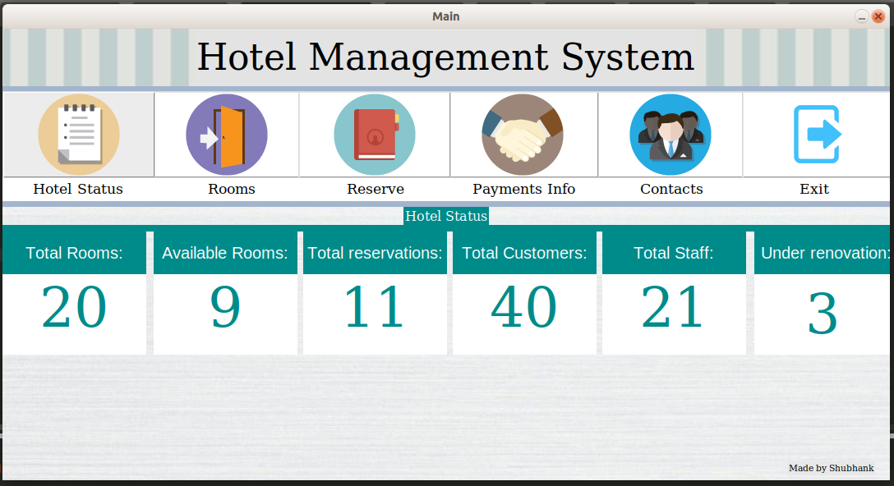

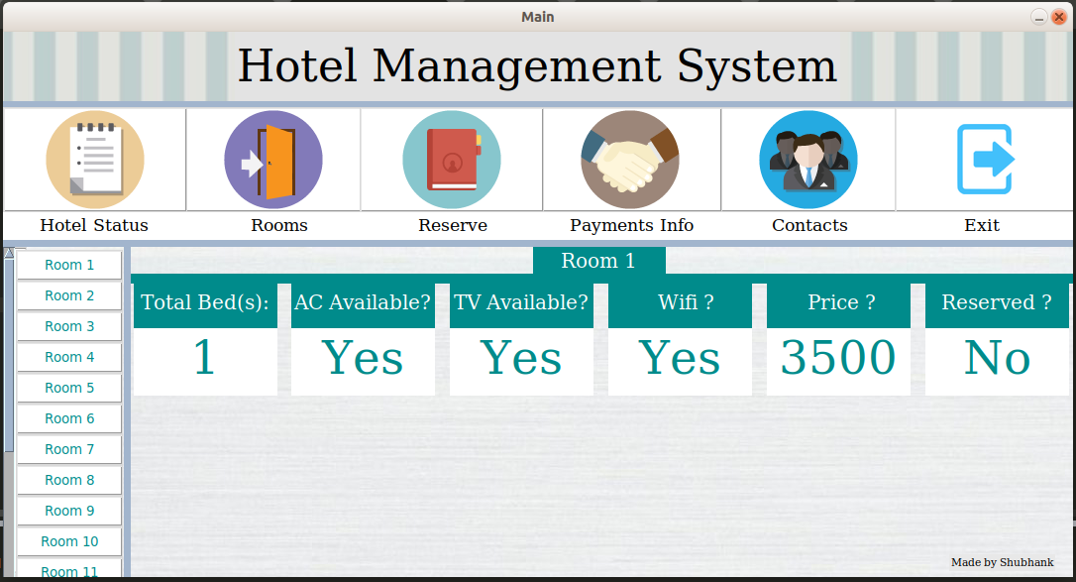 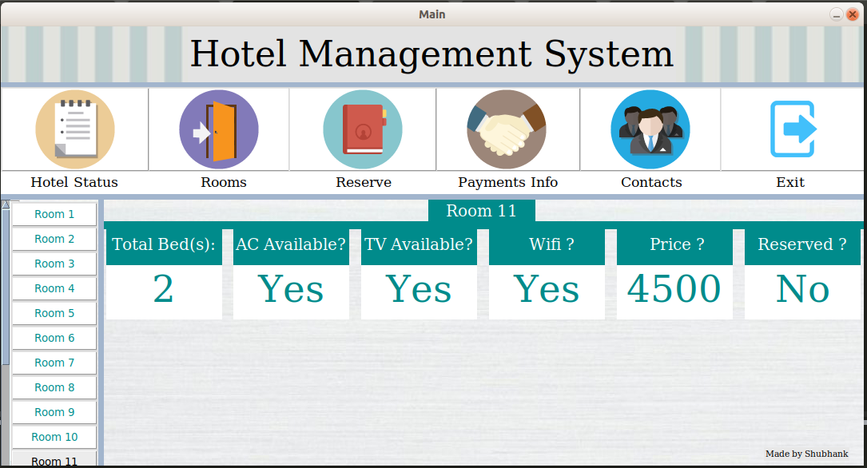

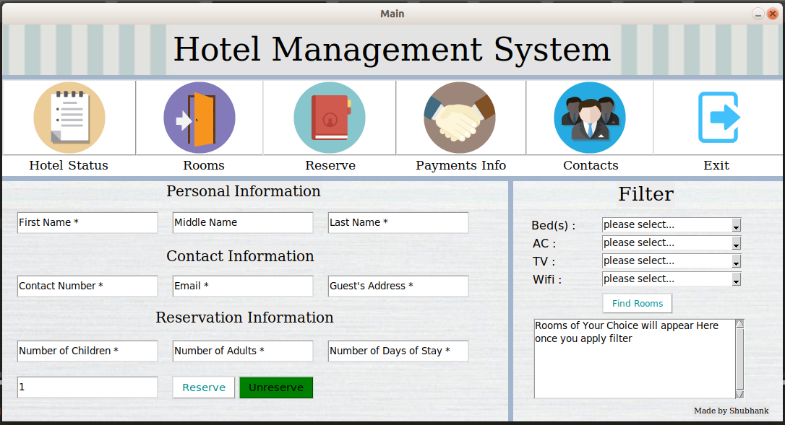 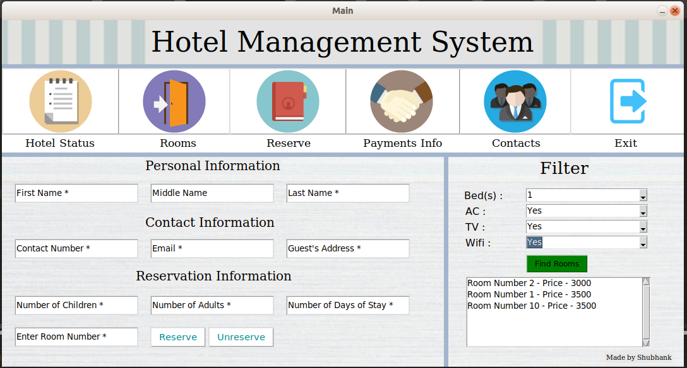

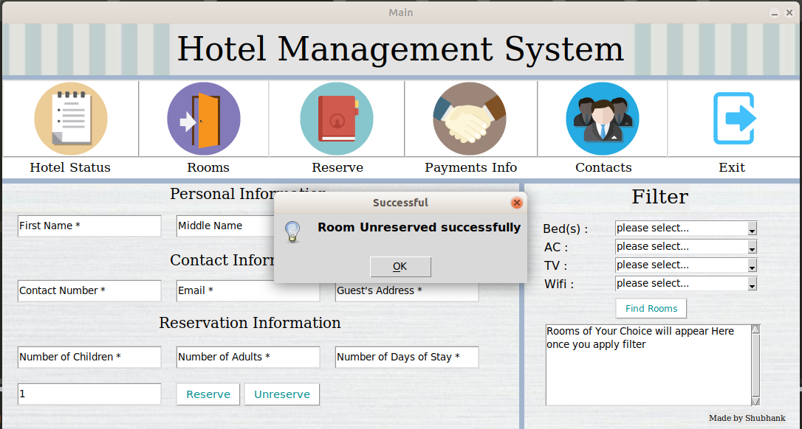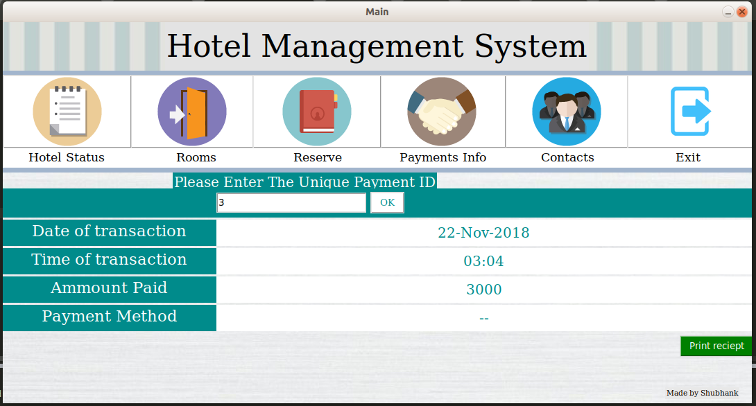

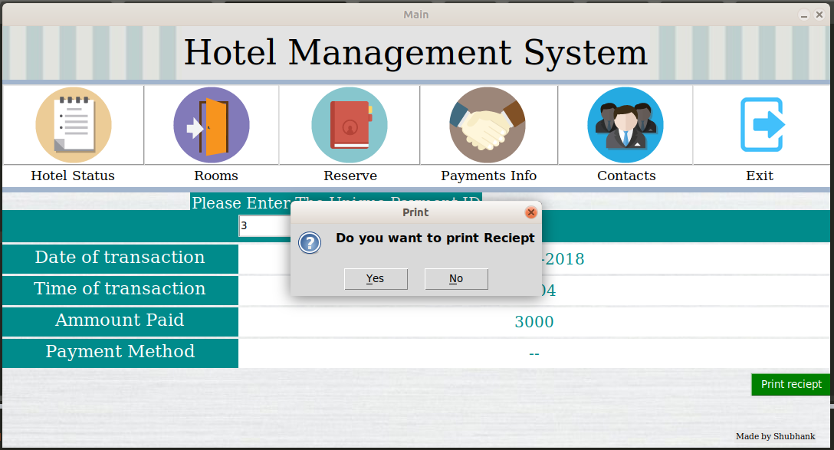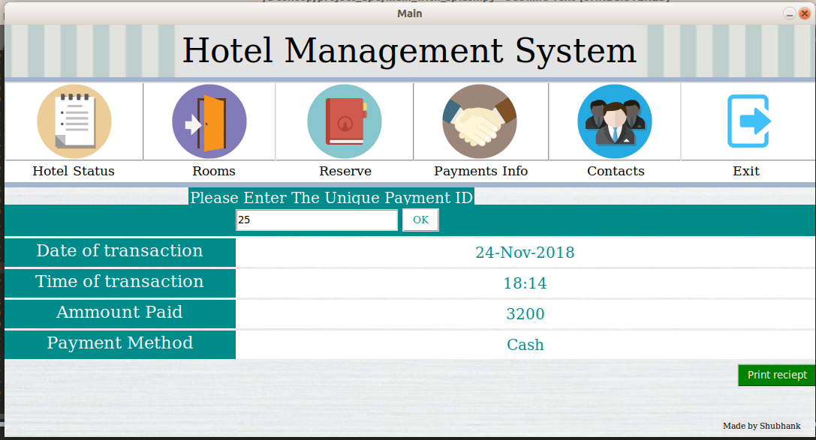

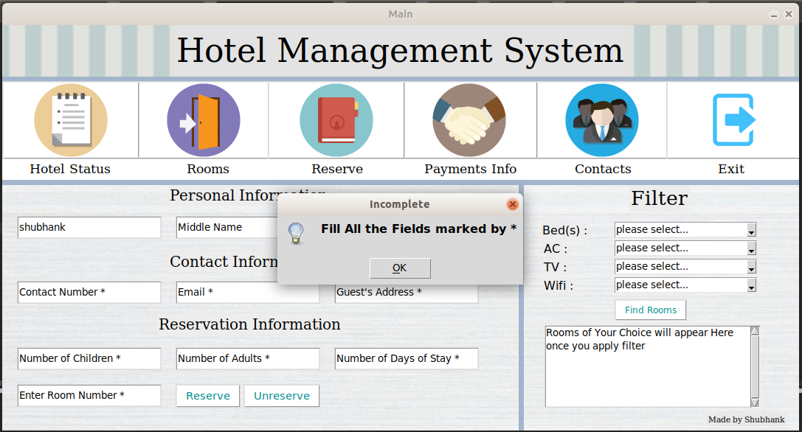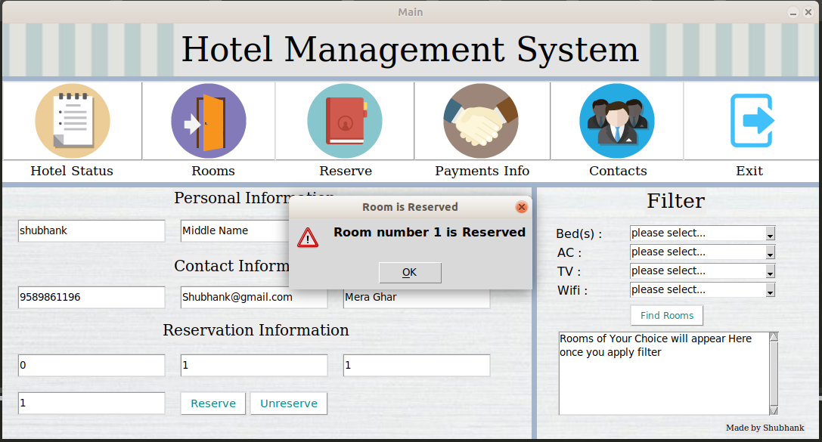

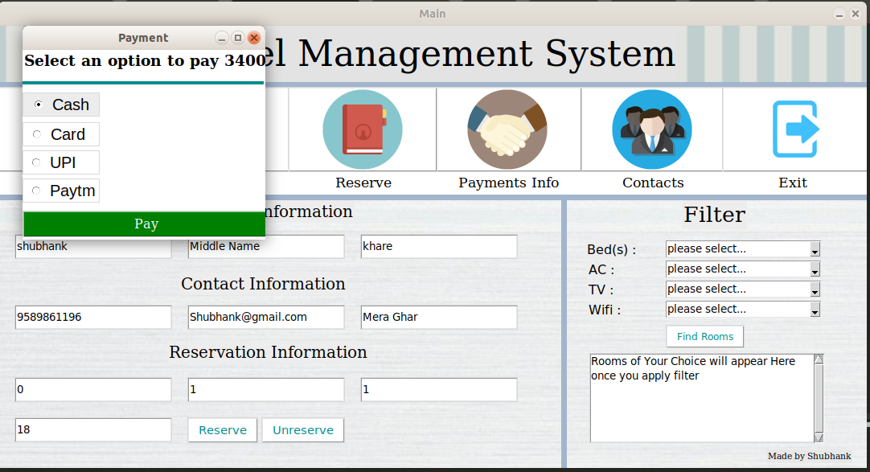

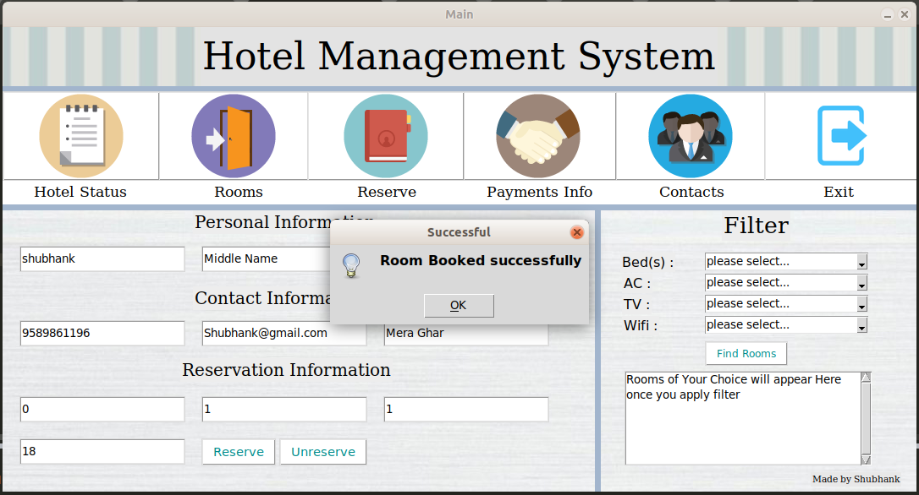

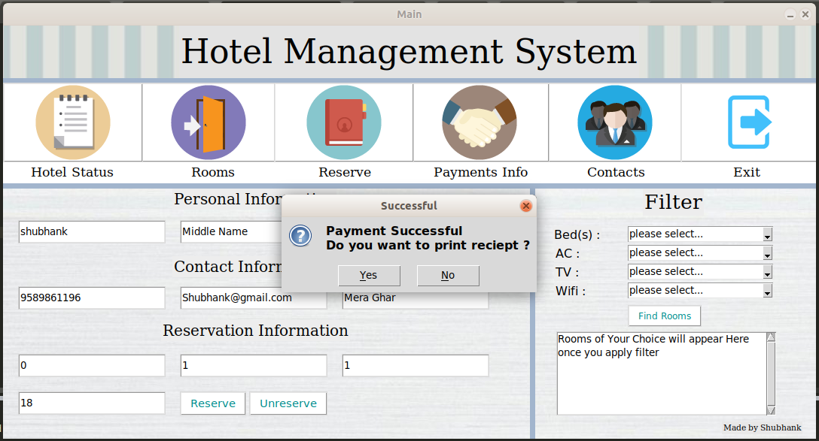

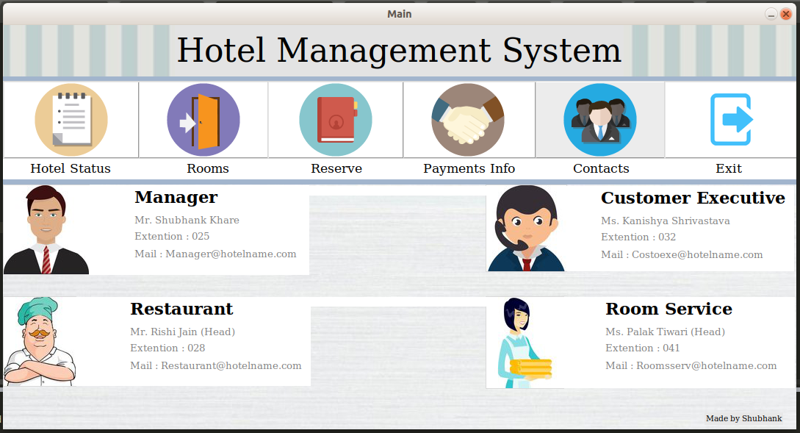

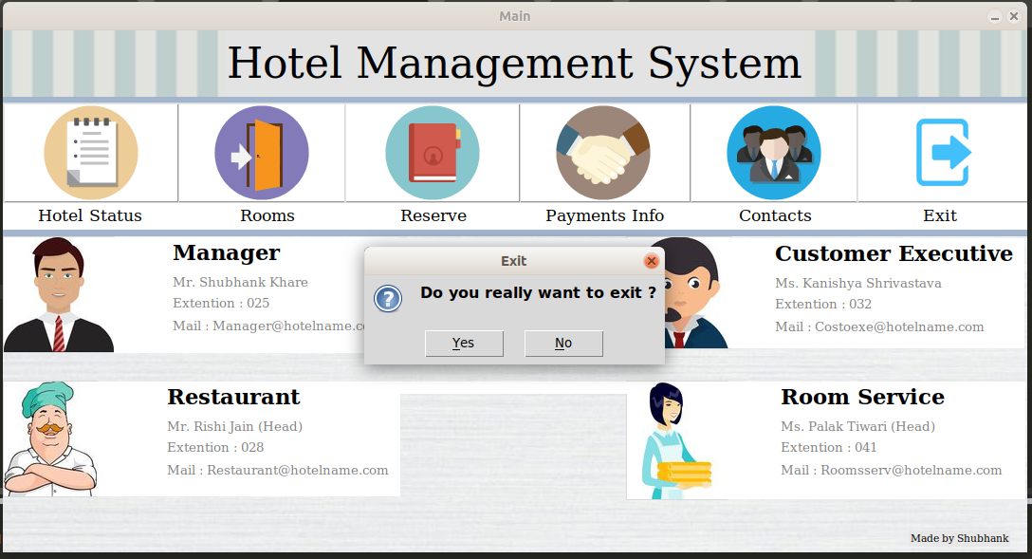

References

* Classroom Notes
* Stack Overflow (To Solve errors)
* Google.com

